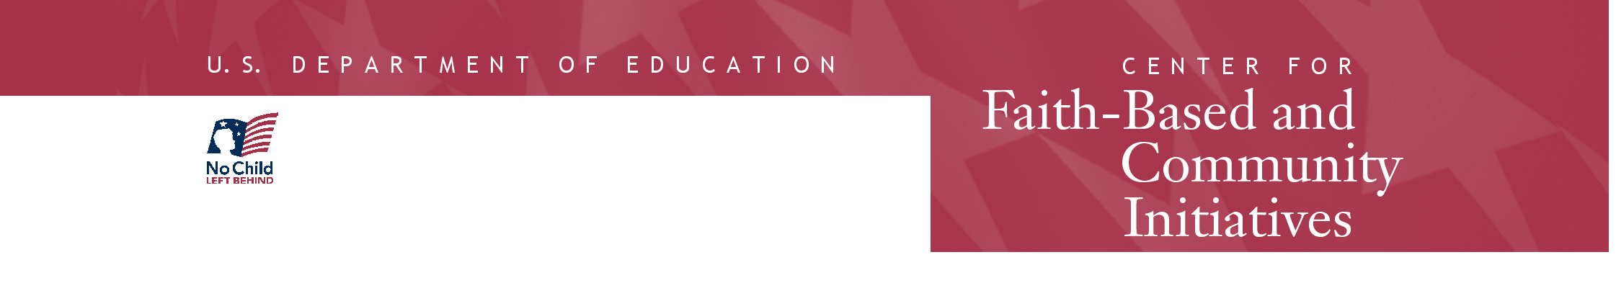
October 30, 2003
Memphis Cook Convention Center, Ballroom C
255 North Main Street
Memphis, TN 38103-1623

Both workshops are free, but pre-registration is required. Registration is on a first-come, first-served basis.
Please register by October 24, 2003. There is a limit of two individuals per organization.
 Supplemental Services Workshop – 9:00 am – 12:00 noon  
 21st Century Community Learning Centers Workshop – 1:00 pm – 4:00pm
 Both Workshops

Name
Organization
Address
City State Zip Code
Phone Number Fax Number
Email
Web Site

Name
Organization
Address
City State Zip Code
Phone Number Fax Number
Email

Services Offered Please check all that apply.
 Abstinence  Academic  After-School Program  At-Risk Youth
 Elderly  Health Care Provider  Homelessness  Housing
 Hunger  Juvenile Justice  Mentoring  Prison Ministry
 Substance Abuse  Tutoring  Welfare-to-Work  Other (please describe)

Have you ever received government funding?  Yes  No If yes, please describe

Please fax this form to Stephanie Robinson-Kimble at 202-208-1689. If you have any question, please call 202-219-1741.
OMB# 1800-0011


